**VizLearn**

**Final Project Report**



**Objective:**

The project proposal document briefly describes the outline of the objectives, goals, function, and implementation plan of the software project. It introduces a system named VizLearn, whose purpose is to make the studies organized and focused for students in grades 1 to 12.

This document also includes goals, consequences, outcomes, and the steps for implementation of the project, along with a detailed overview of the project and quality management plan.

**Authors**:

|  |  |
| --- | --- |
| Kashish Rakeshkumar Rastogi - 110122772  Tanviben Vipulkumar Trivedi - 110123876  Manjot Singh Plaha - 110122827  Parth Rakesh Patel - 110124289  Harsh Vikrambhai Thakkar - 110124336  Niharika Khurana - 110124290  Neel Maheshbhai Kakadiya - 110100918 | |
| Usama Mir | Written on: 04/06/2023 |
|  |  |

**Submitted to**:

|  |
| --- |
| Designation |
| Dr. Usama Mir |

ID: Document 1

State: **Project Proposal**

**Index Title Page No**

**1 Introduction 5**

**1.1 Document Objective 5**

**1.2 Project Background 5**

**1.3 Project Statement 5**

**1.4 Ecosystem of Problem 5**

**1.5 Project Objective 6**

**1.6 Stakeholders 6**

**2 Market Study 7**

**2.1 Market Analysis 7**

**3 Unique Selling Point 7**

**4 Final SRS 11**

**4.1 Introduction 11**

**4.1.1 Purpose 11**

**4.12 Scope 11**

**4.1.3 Intended Audience 12**

**4.2 Overall Description 12**

**4.2.1 Product Perspective 12**

**4.2.2 Product Functions 12**

**4.2.3 Operating Environment 13**

**4.3 External Interface Requirements 13**

**4.3.1 User Interface 13**

**4.3.2 Hardware Interface 13**

**4.3.3 Software Interface 13**

**4.4 Functional Requirements 13**

**4.4.1 Basic Functionalities 13**

**4.4.2 Course Functionalities 14**

**4.5 Non-functional Requirements 14**

**4.5.1 Usability 14**

**4.5.2 Efficiency 14**

**4.5.3 Security 15**

**4.5.4 Constraints 15**

**4.5.5 Hypothesis and Dependencies 15**

**4.6 Initial SRS v/s Current SRS 15**

**4.6.1 Initial SRS 15**

**4.6.2 Current SRS 16**

**5 A Description Of Tools And Technologies 17**

**5.1 Development Pipeline 17**

**6 Provisional Project Planning 19**

**6.1 The Life Cycle 19**

**6.2 Roles and Responsibilities 19**

**6.3 Team Composition 20**

**7 Sprint Report 22**

**8 Testing Document 26**

**8.1 Scope 26**

**8.2 Testing Strategy 26**

**8.3 Test Plan 27**

**8.4 Manual Testing 27**

**8.5 Test Cases 27**

**8.6 Manual Testing Exit Criteria 42**

**8.7 Conclusion 43**

**9 A Final Design/Architecture 46**

**9.1 Class Diagram 47**

**9.2 Use Case Diagram 48**

**10 Usage of Design Pattern 46**

**11 Final Analysis 49**

**11.1 Estimated Development Cost 49**

**11.2 Estimated Operational Cost 49**

**11.3 Final Cost Analysis 50**

**12 Quality Assurance 51**

**12.1 Version History 51**

**12.2 General Quality Assessment Requirements 51**

**12.3 Quality Assurance 51**

**12.3.1 Quality Management Plan 51**

**13 Risk Management Plan 56**

**14 Pros and Cons of Our Solution 61**

**15 Difficulty Faced During Project 62**

**16 Future Scope 63**

**17 User manual 69**

**18 References 76**

# **1. Introduction**

## **1.1 Document Objective**

The project proposal document briefly describes the outline of the objectives, goals, function, and implementation plan of the software project. It introduces a system named VizLearn, whose purpose is to make the studies organized and focused for students in grades 1 to 12.

This document also includes goals, consequences, outcomes, and the steps for implementation of the project, along with a detailed overview of the project.

## **1.2 Project Background**

We propose developing a mobile app for education with the goal of giving users a personalized learning experience. The app will be comparable to Educative, a well-known online learning platform, but will have additional features to monitor users' actions, assess their progress, and recommend reasonable time frames for various levels of courses.

**1.3 Problem Statement**

In this expeditiously growing digital era, the traditional educational methodology often struggles to provide a personalized and adaptive learning approach for the student, which hinders the student's ability to shine. So, the customer wants to make an educational application where the student can see their strengths and weaknesses for fast learning.

## **1.4 Ecosystem of Problem**

**Social Factors Leading to the Problem:**

* **Diverse Learning system:** learning capacity of students is variable for every student. The traditional method of learning hinders the student's growth with various factors that result in a limiting understanding, failure, or abandonment of a course.
* **Limited individual attention:** In overcrowded classrooms, teachers struggle to provide resources and take time for each student. The lack of teacher attention affects the student's ability to grasp concepts fully and reach their maximum potential in that course.

**Economic factors leading to the problem:**

* **Not having personalized education:** Most of the applications are based on the economy booster model rather than the student-getting knowledge model. There are many instances where the student is unable to complete their course because the courses are based on making money rather than providing insightful resources for students.
* **Limited resources from schools:** Schools having limited funding face challenges in providing up-to-date learning materials, digital infrastructure, and highly qualified teachers. These resources limit the students' effective learning availability and enjoy the learning.

## **1.5 Project Objectives**

In recent years, the field of education has changed enormously. We aim to create a system that will allow students in grades 5–8 to learn visually and textually about various courses. At the end of the project, we desire that our solution will provide a pleasant experience for students who take the course.

The following are the project's primary goals:

* Create a mobile app that provides a variety of instructional courses.
* Create a tracking system to keep track of users' actions and turnaround times.
* Analyse user performance and progress data to produce tailored recommendations.
* Provide users with suggested completion times for courses at various levels of difficulty (easy, medium, and hard).

## **1.6 Stakeholders**

Project Director

* Dr. Usama Mir

Customer

* Mahshad Hashemi

Possible Users

* TechPros
* University, College
* School administrators, students, and Parents
* NGOs
* Private Companies

Others

* Managers
* Developers
* Designers
* QA Tester

# **2. Market Study**

VizLearn ought to address all the needs of the client. The client would be able to watch and read the course and also have additional resources such as quizzes and analysis of their profile.

**Existing solution 1**: Educative

According to the study, “Educative” is a self-help tool created for wide users such as k-12 students, university students, and for professional people too. The application consists of various features starting from introductory lessons, code, and quizzes which are useful for learning. But they don’t provide personal feedback for students which doesn’t allow students to know their full potential. Additionally, not all of their courses provide hands-on learning facilities and quizzes where they can assess their skill level and improve their weak points.

**Existing solution 2:** Duolingo:

Duolingo is a language learning platform that uses AI algorithms to personalize lessons based on the learner's proficiency and learning style. It offers interactive exercises, real-time feedback, and gamification elements to engage and motivate learners. However, it focuses primarily on language learning and may not address the broader educational needs of students.

We overcome all these drawbacks in VizLearn by proposing the following solutions.

* **Adaptive Assessments**: The application will dynamically adjust the difficulty level of the quiz and other assessment material based on the learner's performance and score.
* **Real-time Progress Tracking**: The application will offer comprehensive progress-tracking features that provide students, educators, and parents with detailed insights into individual learning journeys.
* We have included new features such as quiz assessment which will let the student know which topics needed to be brushed and which topics they have to practice more.
* We also provide a feature where the users can see their analysis of their profile for the completed course.

## **2.1 Market Analysis**

Market analysis offers a complete overview of the market as well as ways to reduce market risk. VizLearn market analysis is discussed below:

### **2.1.1 Target Market:**

Educational applications have a large market value in North America specific emphasis on Canada and United States countries. The educational market is growing rapidly in North America. These numbers are still growing, and it is expected to grow by 4.79% in 2028 compared to 2020, which we found in the research done by Globe Newswire [1].

The target audience for the educational application is:

* **1-12 Students**: The application will cater to students from kindergarten through higher education, where they have personal access to various courses.
* **Parents**: They will monitor the student’s progress in the “VizLearn” software application where they will know their child’s skill level.
* **University or College**: The “VizLearn” software application can be adopted by universities or colleges where the application allows quizzes and assessment sections for students.

## **2.1.2 Contraints:**

**User Constraints:**

    The customer has tried different educational applications previously but didn’t find them suitable for time management; therefore, he or she needs a solution to manage time for their studies.

**Technical Constraints:**

None at this time. However, the stakeholders can add more after further meetings.

**Financial Constraints:**

      The user has given a CAD 1 million budget estimate.

## **2.3. Discussion with Industrial experts**

To understand the technical requirements regarding the user problems, we dicuss our idea with an industry expert who has worked professionally in software development.

His name is Mr.Mihir Raval We contacted him through the LinkedIn platform to understand what things need to be considered.

# **3. A Unique Selling Point (USP)**

A Unique Selling Point (USP) is the special thing about a product, service, or company that makes it different and better than its competitors. It's basically the answer to the question, "Why should I buy from you instead of someone else?"

VizLearn offers students a personalized and adaptable learning experience. Based on the learner's success, the app automatically adapts quizzes and assessments. This ensures that students are challenged appropriately and can work on their weaknesses.

The following features make VizLearn different from rest of its competitors:-

**Data-Driven Recommendations**: VizLearn customizes student recommendations based on user performance and progress in the quiz. These suggestions include courses and completion times for easy, medium, and hard difficulties. This helps students plan their studies and make educated judgments.

**Hands-on Learning Opportunities**: VizLearn offers more than simple lessons, it also provides opportunities for hands-on learning. The program includes interesting projects, quizzes, and assessments that make studying more enjoyable and assist students in applying what they've learned in real-world settings. This method of learning facilitates comprehension of what is being taught.

**User-Friendly Interface**: VizLearn puts the user first by featuring an intuitive interface and clean design. The app's goal is to simplify and enhance the educational experience for kids of all ages. The ability to search for courses, view your progress, and organize courses clearly all contribute to a streamlined and effective educational experience.

**Focus on Multiple Subjects and Grades**: Some apps are only appropriate for specific topics or ages, but VizLearn is appropriate for kids in grades 1 through 12 and offers a diverse choice of courses in a variety of subjects. This all-encompassing strategy ensures that students may access instruments for studying a wide range of subjects on a single platform.

# **4. Final SRS**

## **4.1 Introduction**

This section’s main goal is to offer an initial Software Requirements Specification (SRS) for the creation of a mobile educational app. The program has features like tracking user activity, analyzing completion rates for materials and quizzes, and producing suggestions for course levels depending on user success to create a better user experience compared to other learning applications.

**4.1.1 Purpose**

This section shows the software requiements and their specification for the eductaional application named VizLearn.

**4.1.2 Scope**

Users of the educational app will be able to sign up for courses, finish their assigned readings and quizzes, and get tailored course-level suggestions. The system will monitor user activity and examine completion rates to recommend suitable durations for various course levels for better time management.

**4.1.3 Intended Audience**

Educational applications have a large market value in North America specific emphasis on Canada and United States countries. The educational market is growing rapidly in North America. These numbers are still growing, and it is expected to grow by 4.79% in 2028 compared to 2020, which we found in the research done by Globe Newswire [1].

The target audience for the educational application is:

* **1-12 Students**: The application will cater to students from kindergarten through higher education, where they have personal access to various courses.
* **Parents**: They will monitor the student’s progress in the “VizLearn” software application where they will know their child’s skill level.
* **University or College**: The “VizLearn” software application can be adopted by universities or colleges where the application allows quizzes and assessment sections for students.

**4.2 Overall Description**

**4.2.1 Product Perspective**

VizLearn application aims to revolutionize the online educational system experience for users. The application is designed to be accessible and affordable for multiple users in an affordable range. The product is designed in a way that it empowers all the functionality of the online educational application.

**4.2.2 Product Functions**

**Quiz**

User can access the quiz page when they have enrolled in the course. The quiz page shows three different modules

:easy, medium and hard for each course.

**Marketing Voucher**

We will analyze the user activity in the course and store the access time of the users. So, now we can give them seasonal discounts in that particular course and even notify them.

**Course Management**

Users can browse and choose from a list of available courses provided by the system. Users will be able to sign up for courses that interest them.

**Material Completion Tracking**

The system will keep track of how long users take to finish each course's study material. Users will be able to mark completed study materials.

**Quiz Completion Tracking**

The system will monitor how long it takes users to finish quizzes for each course. Users will have the submit option for their quiz answers for review.

**Performance Evaluation**

The system will examine how quickly each user completed their study materials and quizzes. Every course level (easy, hard, and medium) will have an average completion time calculated and stored by the system.

**4.2.3 Operating Environment**

There are limitations for running the VizLearn application we will require the Andriod operating system as it won't run on iOS platforms. The application is able to handle real-time data and multiple users at one given time.

**4.3 External Interface Requirements**

**4.3.1 User Interfaces**

The VizLearn mobile application is simple and easy to use for the user having a simple and clean design. The application has various screens containing pages such as login, sign up, the home page, course page, quiz, notification, and viz chart screen. Users will register in the application then they will able to surf the course in the course page. The search function of the course page helps the user to see all the courses in the applications according to their interset and comfortness.

**4.3.2 Hardware Interfaces**

The hardware interfaces for the VizLaern application require the user to have an smartphone having Android operating system with a stable internet connection with a laptop. An Internet connection is required to access the Quiz and see the user analysis screen. The design of the program supports a wide range of pages, ensuring compatibility with a variety of devices.

**4.3.3 Software Interfaces**

The software interfaces for the VizLearn mobile applications is designed in a way to provide a seamless and simple user experience. The user will require the Android operating system because programming languages and frameworks are installed only for the Android version. The application is designed to handle a large number of users and adat traffic to ensure a smooth and responsive learning experience.

**4.4 Functional Requirements**

**4.4.1 Basic functionalities**

**Register functionalities**

To access the course the user needs to signup using a valid email address and password for registration in the applications.

User will redirect to the login page if they are already registered.

**Login functionalities**

User needs to be registered already to login the application, otherwise they have to first register through the register page.

User needs to enter correct credentials such as valid email address and password to login in the page.

If users forget the password they can change their password using the forget password page.

**4.4.2 Course Functionalities**

**Browse Course**

User can browse courses on various platforms having Android operating system operations. They can choose various courses based on their corresponding interests in particular course.

**Browse Modules**

User is able to browse modules and sub-modules of the courses according to their interest in courses with ease.

**4.5 Non-functional requirements**

**4.5.1 Usability**

The application must have an easy-to-use interface with straightforward navigation.

Users of the app must receive feedback and clear instructions such manual.

**4.5.2 Efficiency**

Concurrent user sessions must be supported by the system without noticeably affecting performance.

Response times for quizzes and study materials should be within reasonable bounds.

**4.5.3 Security**

User data must be safely saved and protected, including personal data and performance metrics.

Mechanisms for user authentication and access control must be put in place to ensure data privacy.

**4.5.4 Constraints**

The app must be created for both mobile platforms iOS and Android.

The project must abide by the university's rules and regulations for user privacy and data protection.

**4.5.5 Hypotheses and Dependencies**

For the purpose of creating the mobile app/software, the development team assumes access to the necessary development tools and technology.

Users will be able to access course materials and submit quiz answers using the system only if there is internet connectivity available

**4.6 Initial SRS v/s current SRS**

Our software application initially was supposed to be Firebase, Python, and SQL according to the initial plans. However, due to abundance issues in the Firebase and not getting the desired output we choose to go with the MongoDB database. Additionally in the backend, we choose to work with Python frameworks but due to having a lot of issues while integrating with the React native we choose Node.js

**4.6.1 Initial SRS**

**Firebase**

We were using the Firebase database for storing data, showing tables directly from the backend. Firebase is used for Real-time Database, Authentication in the backend.

**Current SRS:**

**MongoDB**

MongoDB is an open-source tool used for storing traditional relationship databases. When dealing with a large amount of data MongoDB is a good choice as it is used for high-volume data storage. MongoDB is used for storing, manipulating data, and using CRUD operations.

Due to the change in project requirements, we choose to work with the MongoDB database as

**4.6.2 Current SRS**

**Python**

The Python language is used for backend programming as it offers libraries to deal with the backend side of the software.

**Current SRS:**

**Node.js**

We have used NodeJS over Python as NodeJS apps' performance and responsiveness are remarkable. Node allows us to scale both vertically(adding new nodes to system) and horizontally(adding resources to system)

# **5. A description of tools and technologies**

## **5.1 Development Pipeline**

The development pipeline includes the tools and technologies that we are going to use in the development cycle.

**Github** - We are using Github for managing the code as it is a version control tool for storing and collaborating on the project.

**Jira** - We are using Jira for tracking the tasks and managing them. This tool provided various functionalities such as recording the sprint, assigning the sprint, and keeping a close check on deadlines. Jira provides a custom dashboard to show the progress of the project to the stakeholders.

**React Native** – We are using React Native which serves as a platform for developing applications. As it is an open-source framework that is publicly available for usage.

**Expo** - Expo is a comprehensive platform that streamlines the creation of mobile applications. It offers a range of tools, libraries, and services to hasten the development of apps. Expo allows for the creation of cross-platform apps without the need for separate codebases for different operating systems thanks to JavaScript and React Native.

**Figma** **–** We are using the Figma software for making designs and wireframes for the mobile application.

**MongoDB** - As MongoDB provides complete configuration management, real-time analysis, high-speed logging, high scalability and supports online mode mongoDB is optimal solution as compared to that of Firebase.

**NodeJS** - We have used NodeJS over Python as NodeJS apps' performance and responsiveness are remarkable. Node allows us to scale both vertically(adding new nodes to system) and horizontally(adding resources to system)

**SCRUMBAN -** Scrumban is a combination of the two most popular agile development methodologies: Scrum and Kanban. Its aim is to leverage the benefits of both methodologies to improve workflow efficiency and flexibility in software engineering projects. In Scrumban Kanban principles are applied to the scrum framework for developing the system. The Scrumban approach helps the team to focus on the correct strategies and improve the overall process.

Scrumban methodology is discussed below:

* **Define the Backlog:** Establish a prioritized list of tasks or user stories that represent the work to be done. These things ought to be compact, clearly defined, and ready for creation.
* **Set your work limit:** It's crucial to figure out how many projects can be running simultaneously. With this cap, bottlenecks are prevented, and the team is forced to focus on completing jobs before starting new ones.
* **Continuous Flow**: Instead of working on projects in predetermined time-boxed iterations (sprints), the team works on them in accordance with their capacity and WIP restrictions. New tasks are added to the workflow when they are completed.
* **Regular Stand-Ups**: Hold regular stand-up meetings to go over the day's progress, give updates, and address any issues. The focus is on keeping an eye on the workflow and fixing any potential issues.
* **Visualise Workflow**: Use a visual board, such as a Kanban board, to monitor the status of work items. The board often comprises columns for each of the numerous process stages, such as "To Do," "In Progress," and "Done."
* **Collaborative Decision-Making:** Encourage open communication and cooperation among team members while making choices as a group. Give the team the freedom to organize itself, take the initiative, and decide as a unit.
* **Adapt and Evolve:** Constantly adapt the ScrumBan approach to the demands, recommendations, and project requirements. Increase flow and provide value more effectively by modifying the process, WIP limitations, or other elements.

ScrumBan is a flexible technique, the precise implementation procedures can change according to the needs of the team and the project. To make sure the strategy is in line with the aims and objectives of the team, it is crucial to continuously examine and modify it.

# **6. Provisional Project Planning**

Throughout the entire life cycle of the project, we will use the Scrumban framework. It helps in team production, development, testing, and development process.

## **6.1 The Life Cycle**

Our lifecycle included the task assigned at each stage of the project by breaking it down into simple steps which we carried out throughout the project.

The team conducted several meetings, group discussions, and research about the project daily and weekly about the project. Every task assigned and completed is accessible through Jira in the form of tickets, which will showcase the whole process to the stakeholder and the progress of the project.

## **6.2 Roles and Responsibilities**

|  |  |  |  |
| --- | --- | --- | --- |
| **Sr. No** | **Name** | **Role** | **Description** |
| 1 | Kashish Rakeshkumar Rastogi | Business Analyst, Frontend Developer | Responsible for making documents regarding the project.  Provide a clean and efficient mobile application design for the system and also work on data visualization for user analysis. |
| 2 | Tanviben Vipulkumar Trivedi | QA Tester, Business Analyst | Make documents regarding the project.  Responsible for detecting possible errors in the system, and performing the test cases. |
| 3 | Harsh Vikrambhai Thakkar | Backend Developer | Provide clean and error-free code, debug the problems related to the system. |
| 4 | Parth Rakesh Patel | Backend Developer | Provide clean and error-free code, debug the problems related to the system. |
| 5 | Neel Maheshbhai Kakasiya | Frontend Developer | Provide clean and error-free design code, debug the problems related to the system. |
| 6 | Manjot Singh Plaha | Frontend Developer, SCRUM Master | Help the team in applying the Scrum framework, plan the meeting, and manage the sprint activity.  Provide clean and error-free design code |
| 7 | Niharika Khurana | Backend Developer, Database Engineer | Provide clean and error free code, debug the problems related to the system. |

## **6.3 Team Composition**

Our team consists of a Scrum master, 3 Front-End developers, 3 Back-End developers, Business Analyst and QA Tester. These roles are assigned based on the qualities and skills which they bring to the team.

**SCRUM Master**: Is skilled in planning and proposing the sprints, taking regular updates from team members through meetings or emails.

**Frontend Developer:** The frontend developer produced a clean and concise design for the system. They will implement the code and deploy them after the testing process.

**Backend Developer:** Produces clean and concise code for the system. Their role is to implement the code and deploy them after the testing process. They will seek assistance from BA since their areas of weakness are task documentation and comprehension.

**Business Analyst:** Capable of assigning work, coordinating with team members, and documenting requirements effectively.

**QA Tester:** Are proficient in writing test cases, performing regression testing, and integration testing**.** They will communicate with developers for solving the errors in the system.

**Database Engineer**: t is the responsibility of a database engineer to design, implement, and maintain databases that efficiently manage and store vast volumes of data. They collaborate with programmers and data analysts to build complex queries, build data models, and troubleshoot any issues with data storage and retrieval.

# **7. Sprint report**

**Introduction**

As part of the education project, a mobile app designed for children in grades 1 through 12 will be evaluated for quality, usability, and user experience. The main objective is to develop an app with a wide selection of educational courses, tracking user actions and turnaround times, personalized suggestions based on performance data, and suggested completion durations for courses with varying degrees of difficulty. The assessment procedure seeks to provide the targeted student population with an enjoyable and productive learning experience. 

**Provisional Planning**

**Sprint 1:**

**Start date**: June 2, 2023

**End date**: June 15, 2023

**Objective**:

* Requirement gathering by meeting with the client.
* Understanding needs via meeting with our client Mahshad Hashemi and Professor.
* Setting up the JIRA account for task and sprint management.

**Task Completed**:

* Planning of the project and role division.
* Setting up the JIRA.
* Setting up GitHub.
* Made a cost analysis and market study for the project.

**Deliverable**: Initial SRS

Tasks completed by each member:

|  |  |  |
| --- | --- | --- |
| **Team members** | **Tasks** | **Task-status** |
| Manjot Plaha | Started learning front-end technologies | Done |
| Kashish Rastogi | Worked on Project Proposal documentation | Done |
| Tanviben Trivedi | Worked on Project Proposal documentation | Done |
| Neel Kakadia | Started learning front-end technologies | Done |
| Parth Patel | Worked on a market study for a project proposal | Done |
| Harsh Thakkar | Started learning back-end technologies | Done |
| Niharika Khurana | Started learning back-end technologies | Done |

**Sprint 2:**

**Start date**: June 16, 2023

**End date**: June 28, 2023

**Objective**:

* Design Front-end and UI wireframes so that the customer/client can approve the design.

**Task completed**:

* Developed front-end login screen
* Developed front-end signup screen
* Developed front-end welcome screen
* Developed front-end password reset screen
* Developed front-end home screen

**Deliverable**: Initial screens of the mobile app.

**Feedback**: The design is not too attractive as this app is for kids so it must be attractive to kids.

**Task completed by each member:**

|  |  |  |
| --- | --- | --- |
| **Team members** | **Tasks** | **Status** |
| Manjot Plaha | Developing the front end for the Signup screen | In-Progress |
| Kashish Rastogi | Developing the front end for the welcome screen  Develop a Reset password screen | Done  Done |
| Tanviben Trivedi | Designing UI frames of the app | Done |
| Neel Kakadia | Developing the front end for the Home screen | Done |
| Parth Patel | Developing the front end for the Login screen | Done |
| Harsh Thakkar | Developing API for the backend | In-Progress |
| Niharika Khurana | Worked on the back end for login API | In-Progress |

**Sprint 3:**

**Start date**: June 29, 2023

**End date**: July 13, 2023

**Objective**: Develop Front-end and Back-end APIs

**Task Completed**:

* UI for Signup screen, Login screen, Logout screen, Home screen, Reset Password screen
* API for Login, Signup.
* Testing of Welcome and signup screen.

**Deliverable**: Modified front-end UI and API for signup.

**Feedback**: Design is good to go and API is also working fine but JWT authentication is needed.

**Task completed by each member:**

|  |  |  |
| --- | --- | --- |
| **Team members** | **Tasks** | **Status** |
| Manjot Plaha | Developing final Sign-up screen | In-Progress |
| Kashish Rastogi | Developing a new login screen  Develop log out screen | Done |
| Tanviben Trivedi | Developed Quiz screen  Testing Welcome and Signup screen | Done |
| Neel Kakadia | Worked on the Home screen | Done |
| Parth Patel | Testing of the login screen and completing the signup and Login API | Done |
| Harsh Thakkar | Developing the data fetch API | In-progress |
| Niharika Khurana | Designing the database for data storage and worked on signup API | In-progress |

**Sprint 4:**

**Start date**: July 14, 2023

**End date**: July 23, 2023

**Objective**: Develop Front-end and Back-end APIs

**Task completed:**

* All the APIs and front end are ready to go.
* Testing of all the APIs and front end.
* Resolve the bugs faced by the tester.

**Deliverable**: Prototype/beta version of VizLearn.

|  |  |  |
| --- | --- | --- |
| **Team members** | **Tasks** | **Status** |
| Manjot Plaha | Developing video controller  User profile screen and testing the APIs | Done |
| Kashish Rastogi | Developing Chart screen  Made a testing document for the course page  Developed vizchart screen | Done |
| Tanviben Trivedi | Developed a Marketing voucher screen  Performed testing for the home screen and quiz screen  Made testing documentation integrating all the pages testing. | Done |
| Neel Kakadia | Developed notification screen and completed Home screen | Done |
| Parth Patel | Developed a timer API to store the start and time of the course in the database and worked on the sprint report.  Completed testing for the login screen. | Done |
| Harsh Thakkar | Completed the data fetch API, worked on the Quality Assurance plan, and Integrated the API with the front end. | Done |
| Niharika Khurana | Developed course page for front end. | Done |

# **8. Testing Document**

**8.1 Scope**

As part of the education project, a mobile app designed for children in grades 1 through 12 will be evaluated for quality, usability, and user experience. The main objective is to develop an app with a wide selection of educational courses, tracking user actions and turnaround times, personalised suggestions based on performance data, and suggested completion durations for courses with varying degrees of difficulty. The assessment procedure seeks to provide the targeted student population with an enjoyable and productive learning experience.

## 

**8.2. Testing Strategy**

Determining the general approach and methodology for testing the mobile app created for students in grades 1-12 constitutes a testing strategy. Here is a thorough testing approach:

1. Test Scope: Define the testing scope, concentrating on crucial features and functionalities that support the project's main objectives.

2. Test data and environment: Create a simple test environment with the devices and operating systems the target audience will most likely utilise to cover common user scenarios and course options, and provide basic test data.

3. Test Cases and Scenarios: Create a limited number of test cases and scenarios that cover the most important features of the app, such as course selection, tracking, and suggestion generation.

4. Performance and Usability Testing: To receive feedback on the app's usability, run a simple usability test with a small group of students from the desired age group. Run some simple performance tests to make sure the app responds quickly and loads pages quickly enough.

5. Validation and Regression: To verify that new modifications don't damage old functionalities, implement simple regression testing. Verify the tracking system's and the data analysis algorithm's basic accuracy.

This straightforward five-step testing procedure offers a targeted and effective testing process that considers the critical features of the mobile app while aiming for a more constrained scope and resource allocation. It enables prompt feedback and the identification of urgent problems, ensuring the app achieves its main objectives for students in grades 1-12.

**8.3. Test Plan**

Our test strategy outlines the testing methodology, goals, and available resources for a project. To guarantee that the system is adequately tested and fulfils the required quality requirements, a testing process roadmap should be provided. This test scope outlines the subject matter being examined.

**8.4. Manual Testing**

The accuracy of the tracking system, user registration, course selection, and recommendation creation are all tested manually. Along with error handling validation, it involves testing for usability, performance, and security. Along with accessibility features, navigation, localization, and compatibility are all examined. Examining the paperwork guarantees thorough testing, resulting in a positive learning experience for the pupils.

**8.5.Test Cases** :

* **Welcome Page:**

|  |  |  |  |  |
| --- | --- | --- | --- | --- |
| Test ID | Description | Expected Result | Actual Result | Status |
| TCW_1: Welcome Screen Display | When the app is launched, make sure the welcome screen is displayed appropriately. | The app's logo, welcome message, log in and sign-up button will be shown on the home screen. | The app's logo, welcome message, log in and signup buttons are shown on the home screen. | PASS |

* **Login Page:**

|  |  |  |  |  |
| --- | --- | --- | --- | --- |
| Test ID | Description | Expected Result | Actual Result | Status |
| TCL_1: Display Login Screen | Check to see if the login screen appears when the programme launches, or if the user navigates to the login page. | A login button and the login screen, which includes password, email, and username entry boxes, should be visible. | A login button and the login screen, which includes password, email, and username entry boxes are displayed. | PASS |
| TCL_2: Login Validation | Test the login verification to make sure users must enter legitimate credentials to log in. | If the login is successful, the user ought to be taken to the app's dashboard or main page. If the login is successful, the user is taken to the app's dashboard or main page. | The user is taken to the app's home page. | PASS |
| TCL_3: Invalid Login Attempt | Verify the user's behaviour when they enter incorrect login information. | An error message informing the user of the failed login attempt should appear. | An error message informing the user of the failed login attempt is shown. | PASS |
| TCL_4: Password Masking | Make sure the password entry field is hidden and does not display the characters typed. | For security reasons, the entered characters should be disguised (for example, shown as dots or asterisks). | The entered characters for the password are hidden. | PASS |
| TCL_5: Forgot Password Link | Verify that the "Forgot Password" link or button takes you to the password recovery/reset page and is active. | The app should navigate to the password recovery/reset page. | The app redirects to the reset password page. | PASS |
| TCL_6: Error Handling | When there are problems with the login process (such as server faults or network issues), test the app's error handling. | When login-related problems arise, the app ought to display the proper error messages. | When login-related problems arise, the app displays the proper error messages. | PASS |
| TCL_7: Accessibility | Check to see if people with impairments can access and use the login screen. | The login screen should work with screen readers and provide accessibility features. | The login screen works with screen readers and provides accessibility features. | PASS |

* **SignUp Page**:

|  |  |  |  |  |
| --- | --- | --- | --- | --- |
| Test ID | Description | Expected Result | Actual Result | Status |
| TCL_1: Show Registration Page | Check to see if the user can access the sign-up area by going to the sign-up page. | Users will be shown the sign-up page, fields for entering a name, email address or username, password, and a sign-up button. | The sign-up page is displayed, complete with sign-up buttons and input fields. | PASS |
| TCL_2: Sign-up Validation | Test the sign-up validation to confirm that users must enter accurate information in order to register. | The user must be directed to the app's home screen if the sign-up is successful. | After signing up, the user is shown the app's home screen. | PASS |
| TCL_3: Mandatory Fields | Check to make sure all required fields are correctly validated and that the user cannot continue without filling them out. | The app should show an error message outlining the necessary fields and disallow registration until they are completed. | The app shows an error message outlining the necessary fields and disallows registration until they are completed. | PASS |
| TCL_4: Password Strength | To verify that users produce strong passwords, test the password strength validation. | The software ought to advise users to set stronger passwords or at least alert them to do so. | The software advises users to set stronger passwords or at least alert them to do so. | PASS |
| TCL_5: Email/Username Uniqueness | Verify that the email and username you used during the sign-up process are genuine and haven't been used before. | If a user enters a username or email address which is already in the database, the app should give a prompt to use the alternative email address and display an error notice. | Notification is given to users to enter a different email address. | PASS |
| TCL_6: Password Confirmation | Make sure the user is asked to confirm their password during sign-up and check that it corresponds with the original password. | The app should show an error notice if the confirmation password does not match the original password as expected. | The app shows an error notice if the confirmation password does not match the original password as expected. | PASS |
| TCL_7: Success Message for Sign-Up | Check to see if a success message or notification appears following a successful sign-up. | The app should display a success message. | The app displays a success message. | PASS |
| TCL_8: Sign-up Failure Handling | When there are problems with the sign-up process (such as server faults or network issues), test the app's error handling. | When troubles with sign-up arise, the app should display the proper error messages. | When troubles with sign-up arise, the app displays the proper error messages. | PASS |
| TCL_9: Accessibility | Check to see if people with disabilities can access and utilise the sign-up page. | The sign-up page should be compatible with screen readers and have the necessary accessibility features. | The sign-up page is compatible with screen readers and have the necessary accessibility features, | PASS |

* **Home Screen:**

|  |  |  |  |  |
| --- | --- | --- | --- | --- |
| Test ID | Description | Expected Result | Actual Result | Status |
| TCH_1: Home Screen Display | Check to see if the app's home screen displays properly afterinstallation. | The app's logo, a welcome message, and opportunities to explore the offered courses should all be shown on the home screen. | The app's logo, a welcome message, and opportunities to explore the offered courses is shown on the home screen. | **PASS** |
| TCH_2: Course Selection Buttons | Make sure the buttons on the home screen for choosing a course are useful and point to the right parts. | The user should be taken to the appropriate course section by clicking on each button for the course selection. | The user is taken to the appropriate course section by clicking on each button for the course selection. | PASS |
| TCH_3: Course Display | Verify that the courses are displayed correctly on the home screen, both visually and textually. | Each course card should have a title, a succinct description, and any pertinent graphics (such as pictures or icons). | Each course card has a title, a succinct description, and any pertinent graphics (such as pictures or icons). | PASS |
| TCH_4: Access to Course Details | Make sure clicking on a course card takes you to the correct course details page. | The app should direct the user to the course's detailed page, which will provide them access to further details. | The app directs the user to the course's detailed page, which will provide them access to further details. | PASS |
| TCH_5: App Logo Navigation | Check to see if returning to the home screen from any other page requires clicking the app's logo on the home screen. | The user should always be taken back to the home screen after clicking the app's logo. | The user is always be taken back to the home screen after clicking the app's logo. | FAIL |
| TCH_6: User Experience | Examine the home screen's overall user experience, considering load times, responsiveness, and aesthetics. | The home screen should load rapidly and react to user interactions without delay. The layout must be both visually pleasing and user-friendly. | The home screen loads rapidly and reacts to user interactions without delay. The layout is user-friendly. | PASS |
| TCH_7: Responsiveness on Different Devices | Verify that the home screen functions properly on a range of devices with diverse screen sizes and resolutions. | The home screen should adjust to diverse devices and display properly without any visual or audio issues. | The home screen adjusts to diverse devices and displays properly without any visual or audio issues. | PASS |

* **Course Screen**

|  |  |  |  |  |
| --- | --- | --- | --- | --- |
| Test ID | Description | Expected Result | Actual Result | Status |
| TCC_1: Verify course details page navigation | Make sure that when a user clicks on a course, they are taken to the appropriate course details page. | Clicking on a course should correctly direct the user to that course's information page. | Clicking on a course correctly directs the user to that course's information page. | **PASS** |
| TCC_2: Displaying course information | Check to see sure the course details page contains all the necessary details regarding the chosen course. | The course details page ought to accurately display all the information required about the chosen course. | The course details page accurately displays all the information required about the chosen course. | PASS |
| TCC_3: Check Enrolment Options | Verify sure there are choices for enrolling in the chosen course on the course information page. | Users should have a straightforward choice to enrol in the course on the course details page. | Users have a straightforward choice to enrol in the course on the course details page. | PASS |
| TCC_4: Examine the course requirements | Check that the course's prerequisites or criteria are appropriately displayed on the course information page. | If there are any, the prerequisites or requirements for the chosen course should be made crystal apparent on the course details page. | The prerequisites or requirements for the chosen course are crystal apparent on the course details page. | PASS |
| TCC_5: Check back navigation | Check that the back button or link functions properly when returning from the course information page. | The user should correctly return to the course listing page after clicking the back button or link without any problems. | The user returns to the course listing page after clicking the back button or link without any problems. | PASS |
| TCC_6: Test course image display | Verify that the course image or thumbnail appears correctly on the course details page. | The course image or thumbnail should appear as expected on the course information page. | The course image or thumbnail do not appear as expected on the course information page. | FAIL |
| TCC_7: Information on course fees | Make sure the information about course costs or prices is appropriately shown on the course details page. | The chosen course's pricing information ought to be appropriately shown. | The chosen course's pricing information is appropriately shown. | PASS |
| TCC_8: Verify course registration deadline | Verify that the chosen course's registration deadline (if any) is displayed on the course information page. | If appropriate, the registration deadline for the selected course should be accurately shown on the course details page. | The registration deadline for the selected course is not accurately shown on the course details page. | FAIL |
| TCC_9: Checking course availability | Verify that the course information page accurately displays the selected course's availability status. | Based on the course's enrollment capacity, the course details page should display the selected course's availability status. | The course is available all the time for all the users. | PASS |
| TCC_10: Verify course syllabus | Verify that the syllabus or curriculum for the chosen course is visible on the course information page. | The course syllabus for the chosen course should be appropriately displayed on the course information page. | The course syllabus for the chosen course is appropriately displayed on the course information page. | PASS |

* **Quiz Screen**

|  |  |  |  |  |
| --- | --- | --- | --- | --- |
| Test ID | Description | Expected Result | Actual Result | Status |
| TCQ_1: Level Selection | Check that the user may choose a quiz level (easy, medium, or hard) before the test begins. | After choosing a level, the quiz questions should appear, and the level button should be underlined. | After choosing a level, the quiz questions appear, and the level button is underlined. | PASS |
| TCQ_2: Question Generation | Verify that the questions are displayed on the screen accurately. | After the first question and its possible answers are shown, the timer should begin to count down from 120 seconds. | After the first question and its possible answers are shown, the timer begins to count down from 120 seconds. | PASS |
| TCQ_3: Selection of an answer | Check that the user can choose an answer by clicking on the available choice. | The chosen option must be aesthetically distinguished from other possibilities. | The chosen option is aesthetically distinguished from other possibilities. | PASS |
| TCQ_4: Display of quiz results after completion | Check to see if the quiz concludes with the results screen once all questions have been answered. | A Restart Quiz button, the user's score, and feedback should all be displayed on the result screen. | A "Restart Quiz" button, the user's score, and feedback are displayed on the result screen. | PASS |
| TCQ_5: Restart the exam | Verify the user's ability to restart the quiz after passing it. | The user clicks the Restart Quiz button, the test should start over from scratch and the score should be reset. | The test starts over, and score set to 0. | PASS |
| TCQ_6: Accurate Responses Display | Once the quiz is finished, make sure the right answers are presented. | Each question's accurate responses ought to be shown on the result screen. | Each question's accurate responses are shown on the result screen. | PASS |
| TCQ_7: Submitting Quiz without Answers | Try to submit the quiz without responding to any of the questions. | The quiz should continue and prompt the user to complete all the questions before submitting. | The quiz won’t let the user select next without selecting the answer for the current question. | PASS |
| TCQ_8: Submitting Quiz with Wrong Answers | Answer all the questions, but with false information. | Based on the percentage of right responses, the user's ultimate score ought to be shown. | The user is allowed to select wrong answers and the ultimate score is given. | PASS |
| TCQ_9: Responsiveness | To ensure optimum responsiveness, test the app on various screen sizes and orientations. | The programme should appear appropriately and adapt to various screen sizes and orientations without experiencing any layout problems. | The programme appears appropriately and adapt to various screen sizes and orientations without experiencing any layout problems. | PASS |

* **Marketing Screen**

|  |  |  |  |  |
| --- | --- | --- | --- | --- |
| Test ID | Description | Expected Result | Actual Result | Status |
| TCM_1: Verify Ticket Title | Verify that the ticket component displays the right title in the first test case, "Ticket Title Description Verification." | The title "Discount Voucher" should appear on the ticket component with a font size of 30 and bold formatting. | The title "Discount Voucher" appears on the ticket component. | **PASS** |
| TCM_2: Ticket Description | Confirm that the ticket component displays the correct course description. | The ticket component should display the course description "English Course". | The ticket component displays the course description "English Course" . | PASS |
| TCM_3: Ticket Price | Verify that the ticket component's pricing is accurately presented. | On the ticket component, the anticipated output should be the price. | On the ticket component, the anticipated output is the price. | PASS |
| TCM_4: Ticket Expiration Date | Check to see if the ticket component is showing the right validity date. | The ticket component should display the validity date "Valid until: date” | The ticket component displays the validity date. | PASS |
| TCM_5: Test Component Props | Pass several properties (title, description, and date) to the Ticket component and make sure the shown data is accurate. | The Ticket component should display the correct title, description, and date according to the props supplied. | The Ticket component displays the correct title, description, and date. | PASS |
| TCM_6: Test Component Responsiveness | Check to see if the ticket component can accommodate various screen orientations and sizes. | The ticket component's layout should adapt responsively to match different screen sizes and orientations without encountering any layout problems. | The ticket component's layout adapts responsively to match different screen sizes. | PASS |
| TCM_7: Test Empty Ticket Component | Pass null or empty props to the Ticket component and observe how it responds. | The Ticket component should handle empty or null properties, handling them without any errors or failures, and, where appropriate, showing default values. | The Ticket component handles empty or null properties, handling them without any errors or failures, and, where appropriate, showing default values. | PASS |

* **Profile Page**

|  |  |  |  |  |
| --- | --- | --- | --- | --- |
| Test ID | Description | Expected Output | Actual Output | Result |
| TCP_01: Profile Information Display | Check to see if the user's name, email address, and age are presented properly on the profile page. | The user's Name, Email, and Age should be displayed on the screen and should match the test data that has been submitted. | The user's Name, Email, and Age displays on the screen. | PASS |
| TCP_02:Profile Picture Icon | Verify that the profile picture symbol (bar-chart) is discernible next to the Name section in the test case for the profile image icon. | The icon for the user's profile photo should appear on the screen next to their name as expected. | The icon for the user's profile photo appears on the screen next to their name as expected. | PASS |
| TCP_03:Data Validation | Verify that the email format used in the test case for email validation, which is displayed on the profile page, is appropriate. | The details should have the right format and a valid email address. | The details have the right format and a valid email address. | PASS |
| TCP_04:Handling Errors | Test situations where errors might occur, such as when the user's Name, Email, or Age are missing or incorrect. | The program should smoothly handle errors, show pertinent error messages, and guard against any unexpected crashes. | The program should smoothly handle errors, show pertinent error messages, and guard against any unexpected crashes. | PASS |

* **API Testing**

|  |  |  |  |  |
| --- | --- | --- | --- | --- |
| Test ID | Description | Expected Result | Actual Result | Result |
| TCA_1 | When user enter his/her data he/she must be signed in | Returns an unique id for specific user. | Returns an unique id for specific user. | 1 |
| TCA_2 | When user tries to login using correct login credentials, API must allow it. | Returns success body response | Returns success body response | 2 |
| TCA_3 | When user tries to login using incorrect login credentials, API must allow it. | Returns failure body response | Returns failure body response | 3 |
| TCA_4 | When user starts any course then set timer API must set timer for that course | Server time must be stored in database | Server time is stored in database | 4 |
| TCA_5 | When user ends any course then timer of that course must be updated | Server time must be updated in database for registering the end time of the course | Server time is entered in database for entering the end time of specific course | 5 |

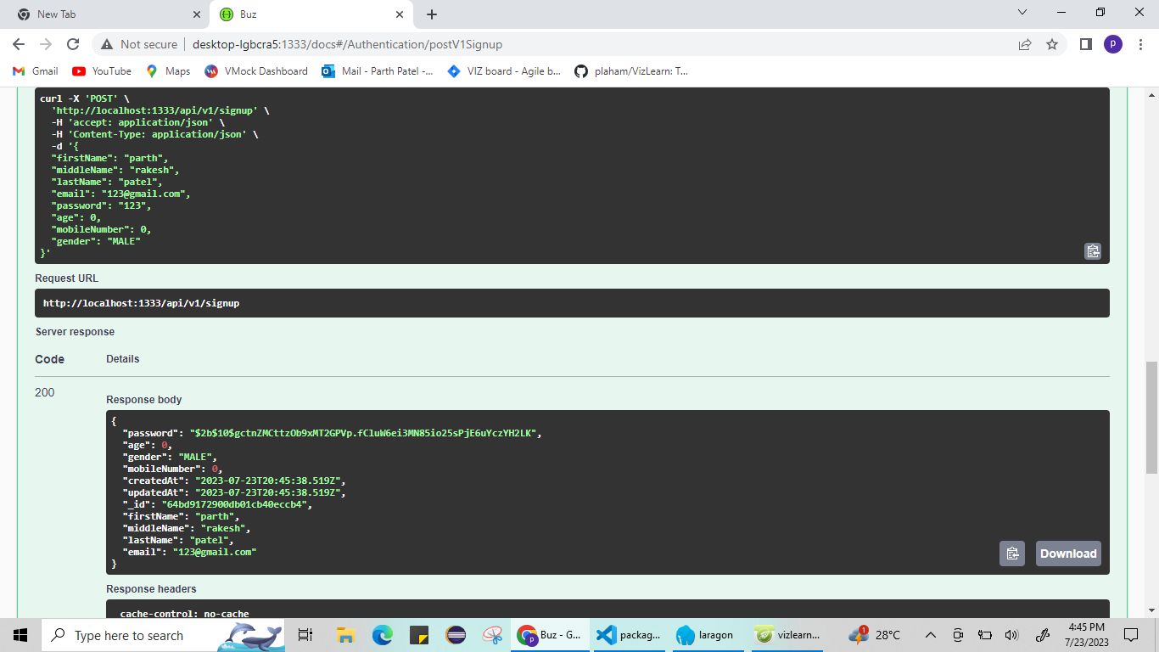

Figure: 1

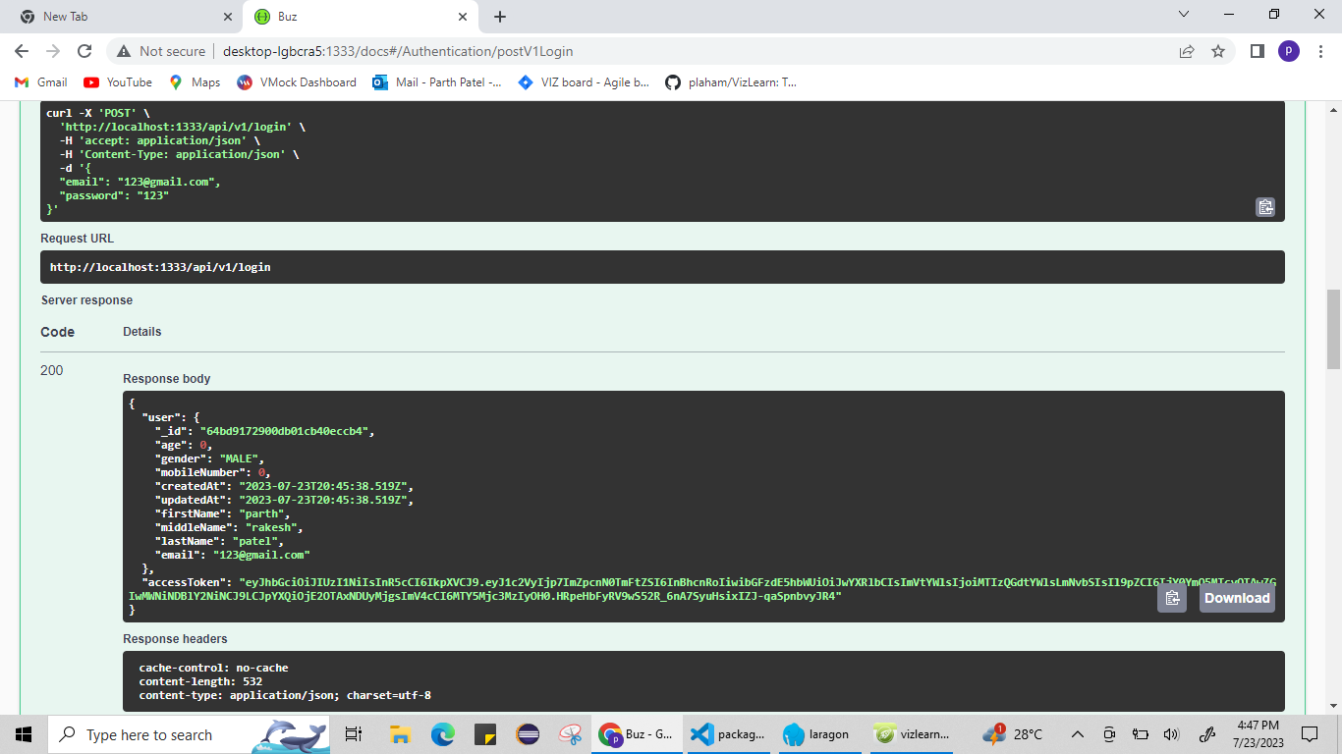

Figure: 2

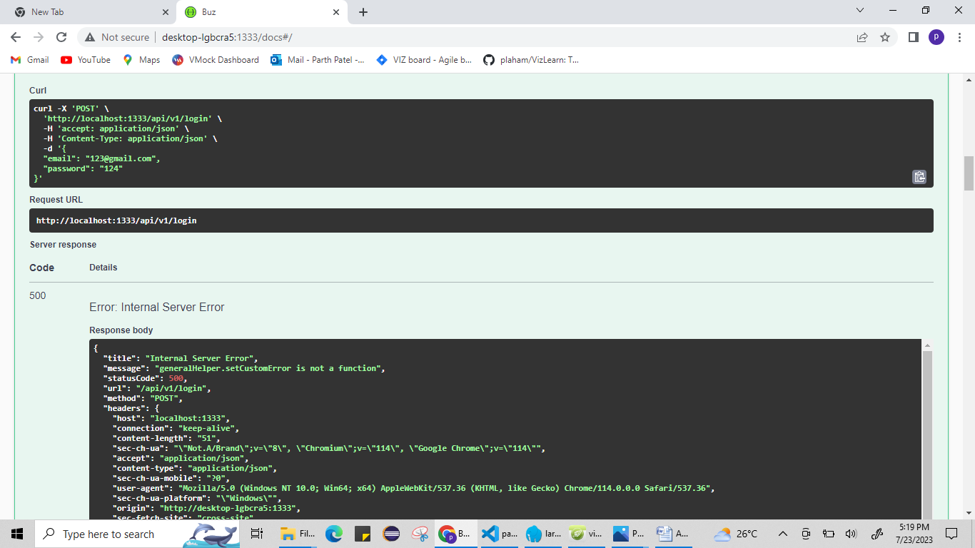

Figure: 3

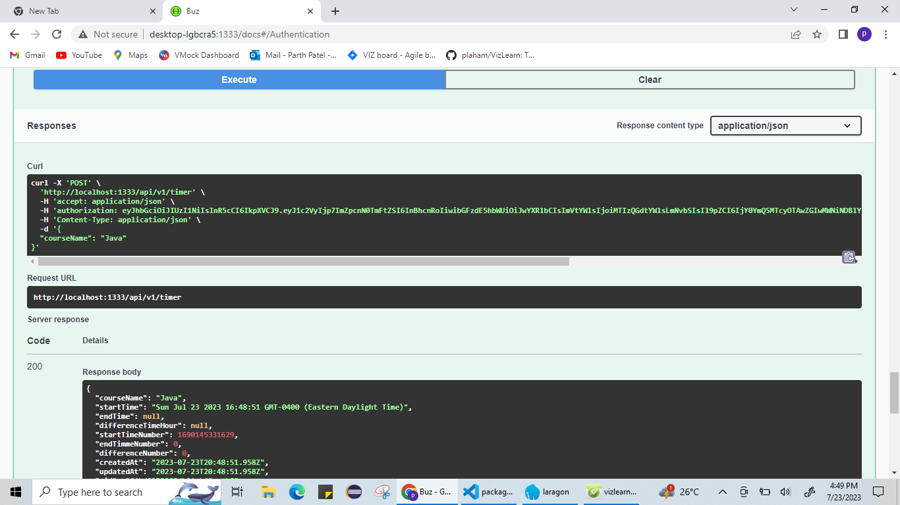

Figure: 4

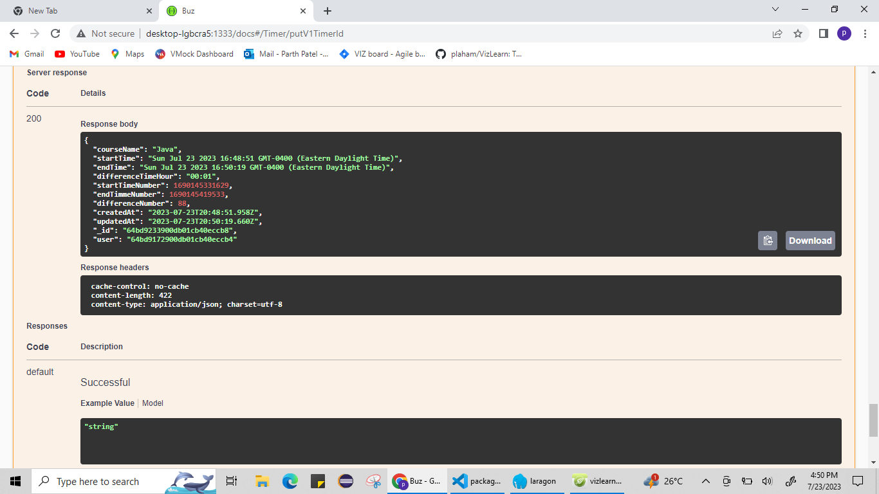

Figure: 5

**8.6. Manual Testing Exit Criteria**

* Every test case has been run.
* The pass rate is greater than a predetermined cutoff point (for example, 95%), and all critical flaws have been repaired.
* The code coverage reaches the predetermined goal, such as 85%.

8.6. Black box -Functional Testing

The main goal of functional testing is to assess the functional specifications or needs of an application.

|  |  |  |
| --- | --- | --- |
| **NO.** | **Functionality** | **Result** |
| **1** | Welcome Page Load | Positive |
| **2** | Navigation Buttons | Positive |
| **3** | Successful Login | Positive |
| **4** | Invalid Login Attempt | Positive |
| **5** | Forgot Password Link | Positive |
| **6** | Successful User Registration | Positive |
| **7** | Verify Existing User Prevention | Positive |
| **8** | Password Strength Validation | Positive |
| **9** | Home page load | Positive |
| **10** | Featured Course Display | Positive |
| **11** | Course Content Load | Positive |
| **12** | Course Sections and Modules | Positive |
| **13** | Video and Text Content | Negative |
| **14** | Quiz Start | Positive |
| **15** | Quiz Questions and Options | Positive |
| **16** | Quiz Submission | Positive |
| **17** | Quiz Scoring and Results | Positive |
| **18** | Coupon code working | Positive |
| **19** | Ticket Tile | Positive |
| **20** | Ticket Description | Positive |

**8.7. Conclusion**

* Here, we attempted to execute automated testing using jest, but it was not totally performed owing to asynchronous testing and external variables. We have also fully performed two testing strategies, namely manual testing, and functional testing from black box testing.
* To conclude, In the software development lifecycle, manual testing is crucial since it allows for human intervention to evaluate the functionality and quality of an application.
* Black box functional testing is essential for ensuring that software complies with specifications and operates as intended from the user's point of view.
* Overall, both tests have shown that 90% of the requirements and functionalities are met by the app.

# **9. An final Design/Architecture**

## **9.1 Class Diagram**

**9.2 Use case diagram**

Use Case Diagram

9.3 System Architecture

9.4 Timeline

Sprint 1

Sprint 2

Sprint 3

Sprint 4

# **10. Usage of Design pattern**

**Observer pattern:**

* We use the observer pattern in the VizLearn application on the Marketing page.
* We have used the observer pattern in a voucher coupon code page where we will store the data of the users who are interested in this course. Then we will give them some seasonal discounts and send them notifications so they can add this course to their cart.
* By following the observer pattern we make marketing choices to give discounts to the user based on analysis.

**Code**:

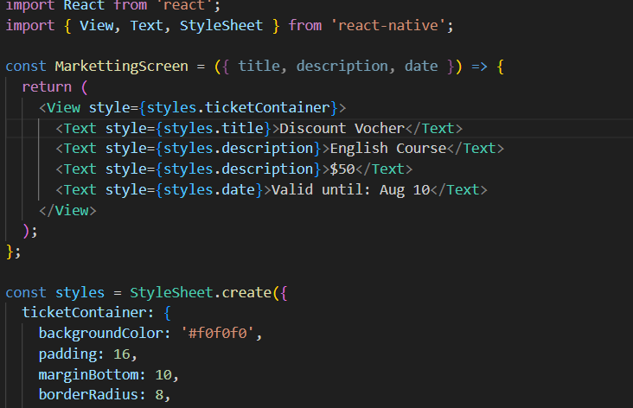

Fig. Observer pattern code

**Singleton pattern:**

* We use the singleton pattern in the main class for the CSS properties in the VizLearn application.
* Here, the main class has all the CSS properties such as themes, color, and fonts for the application. The main class is a global class that is accessible to all the other screens for inheriting the properties.
* By following the singleton pattern it makes the flow of work easy and allows the developer to find out the CSS properties for all the other components in the screens.

**Code**:

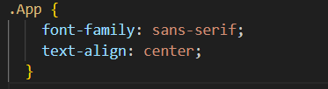

Fig. Singleton pattern code

**Strategy Pattern:**

* We use a strategy pattern for making the quiz grading in the VizLearn application.
* When grading the quiz in the VizLearn application, the strategy pattern can be employed to implement different grading strategies. We have created a GradingStrategy interface with different concrete implementations for various grading methodologies, such as numeric grading, letter grading, or a pass/fail approach.
* By following the strategy pattern we can easily switch between grading strategies without modifying the core assessment grading.

**Code**:

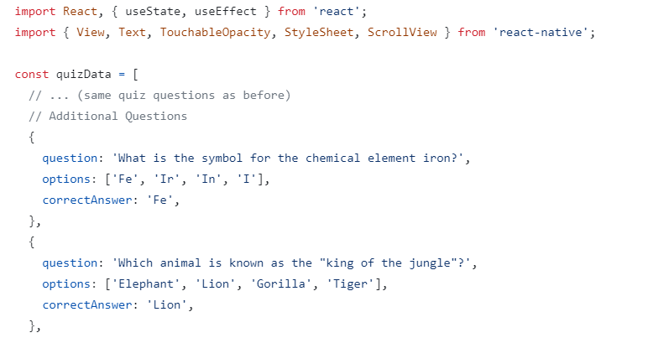

Fig. Strategy pattern code

**Composite Pattern:**

* We use composite patterns for organizing the screen module in the VizLearn application.
* The composite pattern represents a tree-leaf hierarchical organization structure where the screen module represents a tree and various screens such as loginscreen, and singupscreen represent a leaf.
* By following the composite pattern we can easily see the structure of the applications.

**Code**:

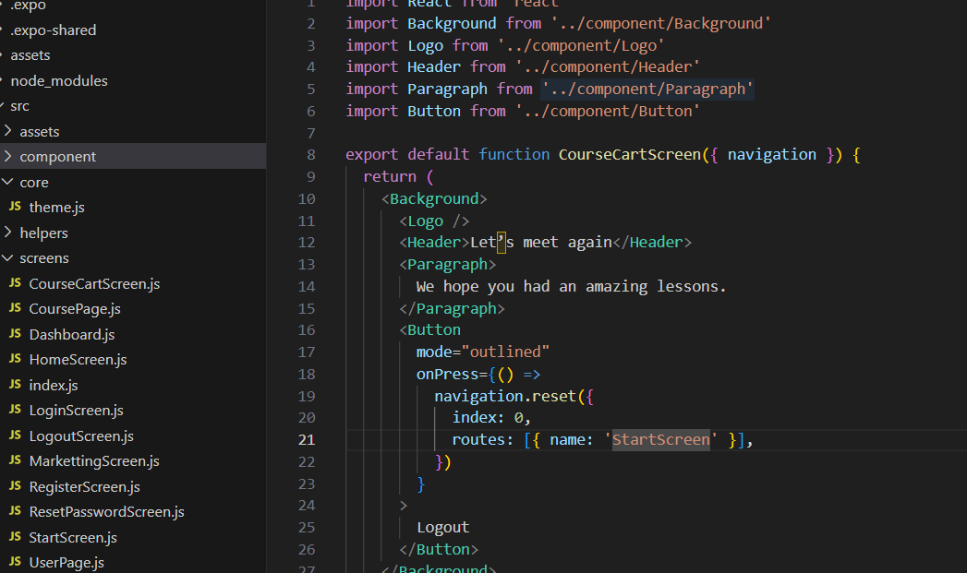

Fig. Composite pattern code

**Template Method Pattern:**

* We use a template pattern for making the quiz module in the VizLearn application.
* When dealing with different types of questions for the quiz. The Template Method pattern is very useful when we can create an abstract assignment class with a template method that defines the overall quiz process. Concrete subclasses can then override specific steps in the process to cater to the requirements of each quiz mode type.
* By following the template pattern we can effortlessly use the template for various grading systems.

**Code**:

Fig. Observer pattern code

# **11. final Analysis**

## **11.1 Estimated Development Cost**

The complexity of the educational app, the intended features and functionality, the platform(s) targeted (e.g., mobile, online), and the rates of the development team can all affect the expected development cost.

|  |  |  |  |  |
| --- | --- | --- | --- | --- |
| **Sr No** | **Item** | **Cost (CAD)** | **Required team** | **Total Cost(CAD)** |
| 1 | Backend Developer | 30000 | 3 | 90000 |
| 2 | Frontend Developer | 25000 | 3 | 75000 |
| 3 | QA Tester | 20000 | 1 | 20000 |
| 4 | Business Analyst | 20000 | 1 | 20000 |
| 5 | Internet Connection Cost |  |  | 500 |
|  |  |  |  | 205500 |

The scale of the project and the materials that will be required throughout its development are taken into consideration when calculating these prices and trying to keep within budget.

**11.2 Estimated Operational Cost**  
The anticipated operational cost for the service may change based on a variety of variables, including the size of operations, the number of users, hosting needs, ongoing maintenance requirements, and support requirements. When assessing operational costs, the main components are as below:

|  |  |  |  |
| --- | --- | --- | --- |
| **Sr No** | **Item** | **Cost (CAD)** | **Total Cost (CAD)** |
| 1 | Hosting | 500 | 500 |
| 2 | Maintenance and Updates | 10500 | 10500 |
| 3 | Licensing and Third-Party Services | 5400 | 5400 |
| 4 | Analytics and Monitoring | 5000 | 5000 |
| 5 | Marketing | 20000 | 20000 |
|  |  |  | 41400 |

Researching the market prices for roles and the software license prices on the websites of the relevant applications are two approaches used to determine these expenses.

Through online component research, we have verified these prices for all the different roles [2][3][4][5].

**11.3 Final Cost Analysis**

The final cost analysis is made while taking care of the project analysis, development, testing, and development phase. We weren’t able to deploy the project. The final cost of the project is evaluated below.

|  |  |  |  |
| --- | --- | --- | --- |
| **Sr No** | **Item** | **Cost (CAD)** | **Total Cost (CAD)** |
| 1 | Licensing and Third-Party Services | 5400 | 5400 |
| 2 | Analytics and Monitoring | 5000 | 5000 |
| 3 | Marketing | 20000 | 20000 |
|  |  |  | 30400 |

# **12. Quality Assurance**

The objective of the quality management plan is to make sure that a high-quality product is provided that satisfies the client's expectations and conforms with the conditions of the contract. The process of quality management is iterative and progressive. The procedure entails determining the standards for quality, planning, putting the plan into action, and carrying it out. The Quality Assurance (QA) team uses the plan after it is put in place to assess, gauge, monitor, and then enhance it.

**12.1 Version History**

|  |  |  |  |  |  |
| --- | --- | --- | --- | --- | --- |
| **Version  Number** | **Implemented**  **By** | **Revision**  **Date** | **Approved**  **By** | **Approval**  **Date** | **Description of  Change** |
| **1.0** | **VizLearn Team** | **<07/22/2023>** | **Tester: Tanviben Trivedi** | **<07/23/2023>** | **Quality Assurnace** |

**12.2 General Quality Assessment Requirements**

1. **Document Reviews:** All the documentation created during project is reviewed by each member, and feedback is given. At the end, the document is approved by the main tester.
2. **Walkthroughs:** A user manual for users and a walkthrough for developers are created for ease of use.
3. **Code Reviews:** Code is reviewed by developers and testers for quality assurance.
4. **Test Result Reviews:** Using manual testing and black box functional testing, test results are generated, and bug fixes are done by developers.

### **12.3 Quality Assurance**

**12.3.1 Quality Management Plan (QMP)**

A quality management plan is a concise document that outlines the approach and activities to be undertaken to ensure that a project or product meets its defined quality requirements.

**Purpose and scope**

Our product provides valuable content to the customer, ensuring that we have completed all the measures in our quality assurance plan. A quality assurance plan ensures that the product meets the demands of the client and makes the necessary changes.

**Quality goals**

The initial stage of a quality management plan is to finish our goals. We have used the following steps to ensure that we have achieved our quality goals:

**1. Roles and responsibilities:**

Documentation Review:

All project documentation will be examined by the QA team before being submitted for approval. Project documentation comes in a variety of forms, such as

|  |  |  |  |
| --- | --- | --- | --- |
| **No** | **Project Document Deliverables** | **Milestone Date** | **Comments** |
| 1 | Project Schedule | 11th June | Planned project with small milestones |
| 2 | Project Charter | 15th June | The created flow of project |
| 3 | Quality Management Plan | 10th July | Standard quality management steps followed |
| 4 | Risk Management Plan | 20th July | Created basic risk plan |
| 5 | Final Report | 24th July | Included all the details of project |

CHECKLIST QUALITY ASSESSMENT OF SOFTWARE DEVELOPMENT FILES

|  |  |  |  |
| --- | --- | --- | --- |
| Item | Description | Yes/No | N/A |
| 1 | Are Software Development files documented? | Yes |  |
| 2 | Are there software development files for each Software Unit? | Yes |  |
| 3 | Are there plans for Software Development Files for each Software Component? | No |  |
| 4 | Are there plans for Software Development Files for each Computer Software Configuration item? |  | N/A |
| 5 | Is software engineering supporting the system requirement review specified in the contract? | Yes |  |

To ensure that our instructional software satisfies the highest standards of quality, the techniques and procedures that will be used are outlined in this quality management plan. By following industry best practises and academic standards, the app strives to give students a simple and effective learning experience.

**2. Quality Objectives**

To receive at least a 4.5 out of 5 rating from users in user satisfaction surveys. To keep the app's interactive parts' reaction times at or below 1 second. To guarantee that there is no more than one serious issue reported each week and that the software remains stable and dependable.

**3. Quality Guidelines**

The software will adhere to all applicable educational standards and regulations, including those pertaining to user accessibility for those with impairments.

To address the accuracy of the content, consistency of the design, and code quality, internal quality standards will be established.

**4. Roles and responsibilities for quality**

* Outlining the roles and responsibilities of the team members helps in managing the quality of the software as each member is designated to complete their task, which smooths the process.
* The QA team evaluates and executes the product in a logical format to ensure that it maintains its standard.
* All the other activities performed by tester are listed below:
  + The tester will plan the whole process making the code and executing it for testing
  + Creating a testing strategy in the planning process of the project
  + Creating test cases simultaneously with the completion of the screen helps make the testing and execution processes faster.
  + Analyzing the flaws and sending a report file to the developer.

**Roles and Responsibilities:**

|  |  |
| --- | --- |
| Qaulity Role | Point of Contact |
| QA Manager | Tanviben, Kashish |
| Test Leader | Parth, Tanviben |
| Developer | Niharika, Harsh |
| Quality Engineer | Manjot, Neel |

**5. Quality Control Procedures**

Senior developers will regularly evaluate the code to find and fix any coding errors. To assess the app's user interface and guarantee a consistent user experience, design reviews will be conducted. A varied set of users will participate in usability testing to confirm the app's functioning and usability.

**6. Testing Techniques**

All app features will be put through functional testing to make sure they function as planned. Usability testing will evaluate how easy it is to use, navigate, and use the app overall. Load times, response times, and overall app speed will be the focus of performance testing.

**7. Bug tracking and problem-solving**

Bugs and issues will be monitored, and their impact will be used to categorize their severity levels. Within the bugs found, the development team will prioritize and fix critical defects.

**8. Risk management**

Potential hazards, such as compatibility problems and data security, that could have an impact on the quality of the app, will be recognised and handled. Risk mitigation measures will be put in place to lessen the effects of potential risks.

**9. User evaluations and satisfaction**

Users will be urged to offer feedback through surveys and in-app feedback options. We'll review user feedback on a regular basis to find opportunities for feature development and improvement.

**10. Release management and version control**

Git version control will be used to track app versions and manage code changes. Only versions that have been extensively tested and approved will be delivered, thanks to the release management procedure.

**11. Documentation**

Users and stakeholders will be given thorough documentation, which will include user guides and technical specifications.

**12. Training and skill improvement**

The development team will participate in ongoing training and skill-building workshops to stay current on the newest techniques and technologies.

**13. Continuous Improvement**

Future iterations of the programme will be improved and the overall quality will be raised using the knowledge gained from earlier releases.

**14. Compliance and Security**

The app will follow data protection laws and guarantee data security using encryption and safe authentication techniques. The implementation of accessibility features will accommodate people with disabilities.

**15. Project Review and Audit**

To evaluate the efficiency of quality management processes and pinpoint areas for improvement, periodic reviews and audits will be carried out.

**16. Appendices**

The appendices will contain test plans, bug reports, and other pertinent papers to support the quality management strategy.

The development team will follow the guidelines in this quality management plan as they work to create an educational app of the highest caliber that offers users a remarkable learning experience. To guarantee that quality stays a high focus throughout the project lifecycle, the plan will be routinely evaluated and modified.

# **13. risk managment plan**

**Risk Management Plan**

This risk management document provides a way to identify and take action on any potential risk that might disrupt the development, or working of the project, or anything that is threatening the project success.

A risk management plan provides the following approach to identify the potential risks:

* Risk Identification
* Risk Evaluation and Analysis
* Risk Documentation
* Risk Control and Management
* Risk Reporting

**Roles and Responsibilities**

This section explains the role of developers, testers, scrum master’s, and product owner’s in discussing and distributing risk-related activities.

The below table shows who would perform, review, and give approval for the activity.

|  |  |  |  |
| --- | --- | --- | --- |
| Risk Activity | Performed by | Reviewers | Approvers |
| Risk Identification | Tanvi Trivedi | Kashish Rastogi | Manjot Singh |
| Risk Evaluation and Analysis | Niharika Khurana | Kashish Rastogi | Manjot Singh |
| Risk Responses | Parth Patel | Kashish Rastogi | Manjot Singh |
| Risk Control and management | Harsh Thakkar | Parth Patel | Niharika Khurana |
| Risk Reporting | Neel Kakadia | Parth Patel | Tanvi Trivedi |

**Risk Identification**

It is the first task that needs to be performed in the Risk management process. Here, all the activities are related to detecting, defining, and cataloging the risk and how it could potentially affect the project.

The risks that might occur and affect project success would be identified by following the below-mentioned techniques.

|  |  |  |
| --- | --- | --- |
| Had a meeting with the client to discuss the project definition. | Meeting with Backend developers, to brainstorm over dependencies on databases and 3rd party APIs | Reviewed similar projects online for risks |
| Went through the documentation thoroughly of each Framework or tool | Conducted sessions with domain experts who have worked on similar projects |  |

The risk can be categorized as follows: (define how it would affect our project)

* Competitor: This can be defined as if another entity tries to launch a similar application before ours under a different name.
* Economic: If, in the future, our app shifts to Payment to Service strategy and during that time an Economic Crisis starts, the users might not use our app, which would be a financial loss to the Organization.
* Schedule: Due to some unforeseen circumstances, the tasks set to be completed in a particular time may not get complete, this could set a delay in delivering the functionality to the client which could cause Financial Loss to the client.
* Data Integrity and Security: There might be a loophole left while coding that might act as a backdoor for a hacker and pose a major Security Threat.

**Risk Evaluation and Analysis**

Each risk will be assessed based on the following factors and categorized based on the appetite of the project.

* Probability of risk happening.
* The risk's potential impact on the project.

Here, the matrix shows the probability of the risk and its various impacts on the project.

|  |  |  |  |  |
| --- | --- | --- | --- | --- |
|  | Probability | | | |
| Impact |  | Low | Medium | High |
| High | Market Competition | Database | Projecting Data on Graphs |
| Medium | Database Integration | Finding Suitable Modules | Data Integrity & Security |
| Low | UI Development | Backend Connectivity | Educational Content |

Legend color:

* **Red**: Substantial Impact on Project Success, has an occurrence probability of 75% or greater
* **Yellow**: Moderate Impact on Project Success, has an occurrence probability of 25-75%
* **Green**: Minimal Impact on Project Success, has an occurrence probability of 25% or less

**Risk Response**

**There are four risk response techniques that may be used to deal with the potential risks that are to be mitigated:**

* **Avoid**: The project team takes action to reduce or eliminate the risk threat or to protect the project from its adverse effects. The scope might need to be narrowed or a technique modified to prevent the risk.
* **Escalate:** When the risk is out of the project’s sphere of influence, it can be moved up or escalated to higher management, where it can be more effectively managed
* **Transfer:** Suppose the impacting functionality is dependent on a third-party vendor, and the risk responsibility is outsourced to that vendor
* **Mitigate:** The project team engages in risk mitigation measures that reduce the chances that a risk threat might occur or to minimize the effect if it does.

**Risk Documentation**

The risk documentation is used to record and manage the risk for documenting. Hence, the minimum documentation to manage the risks will include:

**Risk management plan**, contains the approach defined by all the stakeholders towards handling risks. It contains risk assessment methodologies, response strategies and reporting protocols.

**Risk Reporting Templates**, defines a blueprint in which a risk has to be communicated to stakeholders. This can consist of risk summary reports, graphical representation of risk trends.

**Risk Register**, which contains a history of all the risks which rose back in the time while the development of the project. This acts a reference for future for tackling a similar risks if it came up

**Risk Control and Management**

This is the process by which risks are monitored. All risks will need to be reevaluated on a regular basis since the risk may vary over the project. Every time a project change record is accepted, an assessment will be made to see if either previous risks are impacting or if new risks are emerging

This activity must be repeated periodically to identify new risks, document them in the risk registers, and get them reviewed by stakeholders in risk identification workshops. This activity has to include all sorts of risks that might emerge including market fluctuations, project scope, and business changes.

Risk response residual data may also be included in a risk register. The risk register would also include the predicted effect and probability ratings following risk mitigation actions if a risk was rated as having a high impact and a medium likelihood prior to risk mitigation measures. This makes sure the risk reduction measures are effective and helps to show the benefit of risk response measures.

**Project Risk Assessment**

|  |  |  |  |
| --- | --- | --- | --- |
| Risk Probability/Impact | Number of Risks | Impact Factor | Risk Score |
|  |  |  |  |
| High-High | 3 | 5 | 15 |
| High-Medium | 3 | 4 | 12 |
| High-Low | 4 | 2 | 8 |
| Medium-High | 3 | 4 | 12 |
| Medium-Medium | 7 | 3 | 21 |
| Medium-Low | 5 | 1 | 5 |
| Low-High | 9 | 3 | 27 |
| Low-Medium | 4 | 1 | 4 |
| Low-Low | 19 | 0 | 19 |
| Total Number of Risks | 57 |  |  |
| Total Risk Score |  |  | 123 |
| Risk  Factor (Risk Score/Number of Risks) | |  | 2.1 |
|  |  |  | Medium/High Risk |

|  |  |
| --- | --- |
| Risk Calculation Table |  |
| 0-1 | Low Risk |
| 1-2 | Medium Risk |
| 2-3 | Medium/High Risk |
| 3+ | High Risk |

# **14.**.**pros and cons of our solutions**

**Pros of our solutions**:

* Users will be able to learn topics in which they are lacking with the help of charts shown by the app and suggested courses.
* During the sale, users can purchase the course at a discounted price.
* Marketing of brands will not hinder student learning as students are the first priority for VizLearn above its profit or business.
* Growth of students can be observed.
* As there is a time bound associated with every course’s quiz students will learn time management skills i.e. they will learn to finish things on time.
* Also VizLearn will boost Quick learning capabilities of its students.
* Students will be allowed to take as many retakes of their quiz as they want to improve their score but the number of retakes will be recorded for tracking their growth.

**Cons of our solutions:**

* VizLearn can’t have students who believe only in physical learning by attending in-person classes.
* VizLearn can’t show or trace the growth of student unless the student access the app in online mode i.e. VizLearn will not cater its motive without internet accessibility.
* VizLearn can’t judge whether the course is completed by the desired student or anyone else i.e. if anyone has access to login credentials to anyone’s account then he/she can complete the course on behalf of the account owner.
* Some subjects like Science and Maths require more clarification of questions in exams so this can be challenging for VizLearn to accommodate real-time clarifications of quiz-questions.

# **15**. **Difficulty faced during the project**

This section shows the difficulty faced during the project and we have stated how we resolved this issue. The below are the difficulties faced during the process:

**Selection of technologies**

* In the initial stage, we faced an abundance of problems related to the backend technologies.
* In the beginning, we were using the Firebase database to integrate with the screen, which worked perfectly fine with the small-scale project with some integration, but in the long run, Firebase was getting complex for us, which is why we shifted to the MongoDB database.
* After discussing the feasibility of the project and time, we chose to use Node.js for the backend and MongoDB database for the project.

**Spillover tickets in JIRA**

* Due to the technology selection in the initial stage of the project, the development cycle was slow in the front end and back-end.
* To overcome this situation, we replace the technologies and work on the spillover work by assigning the work of the previous sprint to the next sprint.

**Third-party library compatibility**

* Integrating third-party libraries and modules into React Native becomes a difficult task to accommodate various screen necessity components.

**Data synchronization and real-time updates**

* The VizLearn educational application involves real-time collaboration of the data across multiple platforms, making it difficult to store it in the database for each user. The real time updates of users are a limitation of our project as the API is not working for storing the data.

# **16. Future Scope**

**Accessibility Features**

* Ensuring the application is accessible to users with disabilities can enhance inclusivity. Implementing features like screen reader compatibility and keyboard navigation can improve usability for all users.

**Discount voucher screen**

* To maintain the scalability of the application, on the basis of analysis of purchase time of courses, We would be launching a sale of courses during the specific period of year in which least business was done so that due to lesser price customers will get attracted and buy our course.
* After analysing the user's geolocation and their interest in the courses we will provide seasonal discounts for specific courses.

**Marketing of other brands**

* Scaling the project by sponsoring various brands to advertise their content by keeping in mind that users course content is not explicitly affected.
* We will use brands names and their symbols in various examples in the course which will not affect the user studies.

**Collaborating with Educational institutes**

* Partnering with educational institute and organizations can lead us to potential buyers of this application or event joint partnership to scale the project by funding it.
* Receiving the funding for the VizLearn applications we will introduce video based learning, chat screen for the users.

# **17. User Manual**

**Welcome Screen**

User will first encounter the welcome screen when the app is launched or started.

On clicking the Login button, the user will be redirected to the Login Page. If the user is not registered and is using the app for the first time then the user has to register by entering his/her details.

For this, the user has to click on the Signup button where the user will be redirected to the Signup page.

Fig. Welcome Screen

**Login Screen**

If the user has already registered in the app then he/she has to sign in using the login credentials on the Signin Screen/Login Screen.

If incase, user forgot the password then the user will have to click on text “Forgot your password?” so that user will be redirected to the forgot password screen where he or she can reset the password.If user is not registered or wants to signup then user will click on “Sign Up” so that signup screen is appeared.

Fig. Login Screen

**Signup Screen**

·         If user is not registered then he/she has to register by entering name, email and

**password.**

·         On clicking Signup user will be registered if the entered data is validated and now user can login using login credentials on Login screen.

**Home Screen**

·         On successfully login, user will be redirected to Home Screen where user will find the available courses.

·         Here user can search for the course which he or she is like to have. For this, user can use search bar on the top of the screen or can scroll and look for the desired course.

**Notification Screen**

·         User can navigate to this screen by clicking the notification icon on the bottom of home screen. Here, all the notifications will be shown in the order of Latest first.

**Quiz Screen**

·         This is the page where questions of the quiz would be shown and user has to answer each question based on its type in order to complete the quiz and get the report chart or track the growth.

**Chart Screen:**

Go to user profile where user can find charts regarding progress.

# **18. References**

[1] GlobeNewswire, "North American Education Apps Market to Reach $38.7 Billion Value by 2028," GlobeNewswire, Available: https://www.globenewswire.com/en/news-release/2022/06/23/2467972/28124/en/North-American-Education-Apps-Market-to-Reach-38-7-Billion-Value-by-2028.html, Accessed on: May 27, 2023.

[2] Talent.com, “Backend Developer average salary in Canada, 2023”, Available: <https://ca.talent.com/salary?job=backend+developer>, Accessed on: May 28, 2023

[3] Talent.com, “Frontend Developer average salary in Canada, 2023”, Available: <https://ca.talent.com/salary?job=frontend+developer>, Accessed on: May 28, 20222

[4] Talent.com, “Tester Developer average salary in Canada, 2023”, Available: <https://ca.talent.com/salary?job=tester+developer>, Accessed on: May 28, 2023

[5] Talent.com, “Business Analyst average salary in Canada, 2023”, Available: <https://ca.talent.com/salary?job=business+analyst>, Accessed on: May 28, 2023

[6] Acqnotes (2023, July 23). Quality Management Plan (QMP) [Online]. Available: <https://acqnotes.com/acqnote/careerfields/quality-management-plan-qmp>

[7] “Introducing the new react devtools – REACT BLOG,” – React Blog, https://legacy.reactjs.org/blog/2019/08/15/new-react-devtools.html (accessed Jul. 23, 2023)

[8] M. Verma, “12 powerful react native tools for high productivity,” 12 Powerful React Native Tools for High Productivity, https://www.turing.com/kb/best-react-native-developer-tools (accessed Jul. 23, 2023).

[9] “React native tutorial | full course (2023),” YouTube, https://www.youtube.com/watch?v=YF9NCCOy7P0 (accessed Jul. 23, 2023).

# **19. Additional Links**

Folder Link: <https://drive.google.com/drive/folders/1bF8FF0NUEqEbIqbquaGefUr3Lu6F2wZm?usp=sharing>

Code Link: <https://drive.google.com/file/d/1D2_VVMB9O8reqN18PkbHKyeQMsWv-4RU/view?usp=drive_link>

Video: <https://drive.google.com/file/d/1rrJMGYm7KoamibJ1vCcHUJWEIzLLkyyd/view?usp=drive_link>

GitHub Link: <https://github.com/plaham/VizLearn>

JIRA Link: <https://viz-learn.atlassian.net/jira/software/projects/VIZ/boards/1/timeline>